Project Design Phase-II
Technology Stack (Architecture & Stack)
Date | 4 September 2026
Team ID | Servicenow
Project Name | Automated Network Request Management
Maximum Marks | 4 Marks

Technical Architecture:
The architecture below shows how a network request flows from the Service Portal through validation, approval, and automated fulfilment, and the ServiceNow components and external integrations involved at each stage.
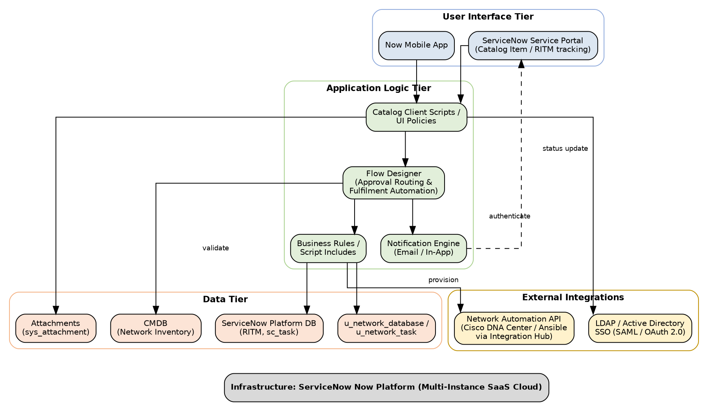
Figure 1: Technical Architecture – Automated Network Request Management (ServiceNow)

Table-1 : Components & Technologies:
S.No | Component | Description | Technology
1. | User Interface | How the requester and approver interact with the application — request submission, status tracking, and mobile access. | ServiceNow Service Portal (AngularJS widgets, Bootstrap), Now Mobile App
2. | Application Logic-1 | Captures and validates catalog item variables on the client side; drives dynamic show/hide behavior of form fields. | Catalog Client Scripts, UI Policies (client-side JavaScript)
3. | Application Logic-2 | Orchestrates the end-to-end request lifecycle — approval routing, escalation, and automated fulfilment task creation. | ServiceNow Flow Designer
4. | Application Logic-3 | Server-side processing — field validation, policy checks, RITM/task status updates, and reusable functions. | Business Rules, Script Includes (server-side JavaScript / GlideRecord)
5. | Database | Core platform data — request items (RITM), catalog tasks (sc_task), and custom variable/fulfilment tables. | ServiceNow Platform DB, u_network_database, u_network_task
6. | Cloud Database | Configuration and network inventory data used to validate and provision requests. | ServiceNow CMDB (Configuration Management Database)
7. | File Storage | Storage for supporting documents attached to a request (e.g., manager authorization). | ServiceNow Attachments (sys_attachment)
8. | External API-1 | Authenticates requesters and approvers against the corporate directory using Single Sign-On. | LDAP / Active Directory Integration, SAML 2.0 / OAuth 2.0 SSO
9. | External API-2 | Executes the actual network configuration change once a request is approved. | Network Automation API — Cisco DNA Center / Ansible via ServiceNow Integration Hub
10. | Machine Learning Model | (Optional / future scope) Suggests catalog category and predicts approval likelihood based on historical requests. | ServiceNow Predictive Intelligence
11. | Infrastructure (Server / Cloud) | Application deployment on Local System / Cloud.  Local Server Configuration: Not applicable — development done on a Personal Developer Instance (PDI).  Cloud Server Configuration: Multi-instance SaaS — ServiceNow-hosted Now Platform (production + sub-production instances). | ServiceNow Now Platform (SaaS / PaaS Cloud)

Table-2: Application Characteristics:
S.No | Characteristics | Description | Technology
1. | Open-Source Frameworks | Front-end widgets on the Service Portal are built using open-source JS/CSS frameworks bundled with the Now Platform. | AngularJS, Bootstrap, jQuery
2. | Security Implementations | Role-based access control on every table, SSO-based authentication, encrypted data in transit/at rest, and secure REST integrations, aligned with OWASP guidelines. | ACLs, SAML 2.0 / OAuth 2.0, TLS 1.2+, Field-level Encryption, MID Server for secure network calls
3. | Scalable Architecture | Multi-tier SaaS architecture where UI, workflow logic (Flow Designer), and data are decoupled, allowing new catalog items, approval chains, and fulfilment flows to be added through configuration. | ServiceNow Now Platform (multi-tier PaaS), Flow Designer
4. | Availability | ServiceNow-managed, geographically redundant data centers with automatic failover ensure the request portal remains available. | ServiceNow High-Availability Cloud Infrastructure (99.9% uptime SLA)
5. | Performance | Platform-level caching of catalog data, indexed custom tables, asynchronous Flow Designer execution for long-running tasks, and CDN-delivered static portal assets keep response times low. | ServiceNow Platform Cache, Asynchronous Flows, CDN

References:
https://www.servicenow.com/docs/bundle/washingtondc-application-development/page/build/service-portal/concept/c_ServicePortal.html
https://www.servicenow.com/docs/bundle/washingtondc-application-development/page/administer/flow-designer/concept/flow-designer.html
https://c4model.com/
https://www.servicenow.com/now-platform.html

